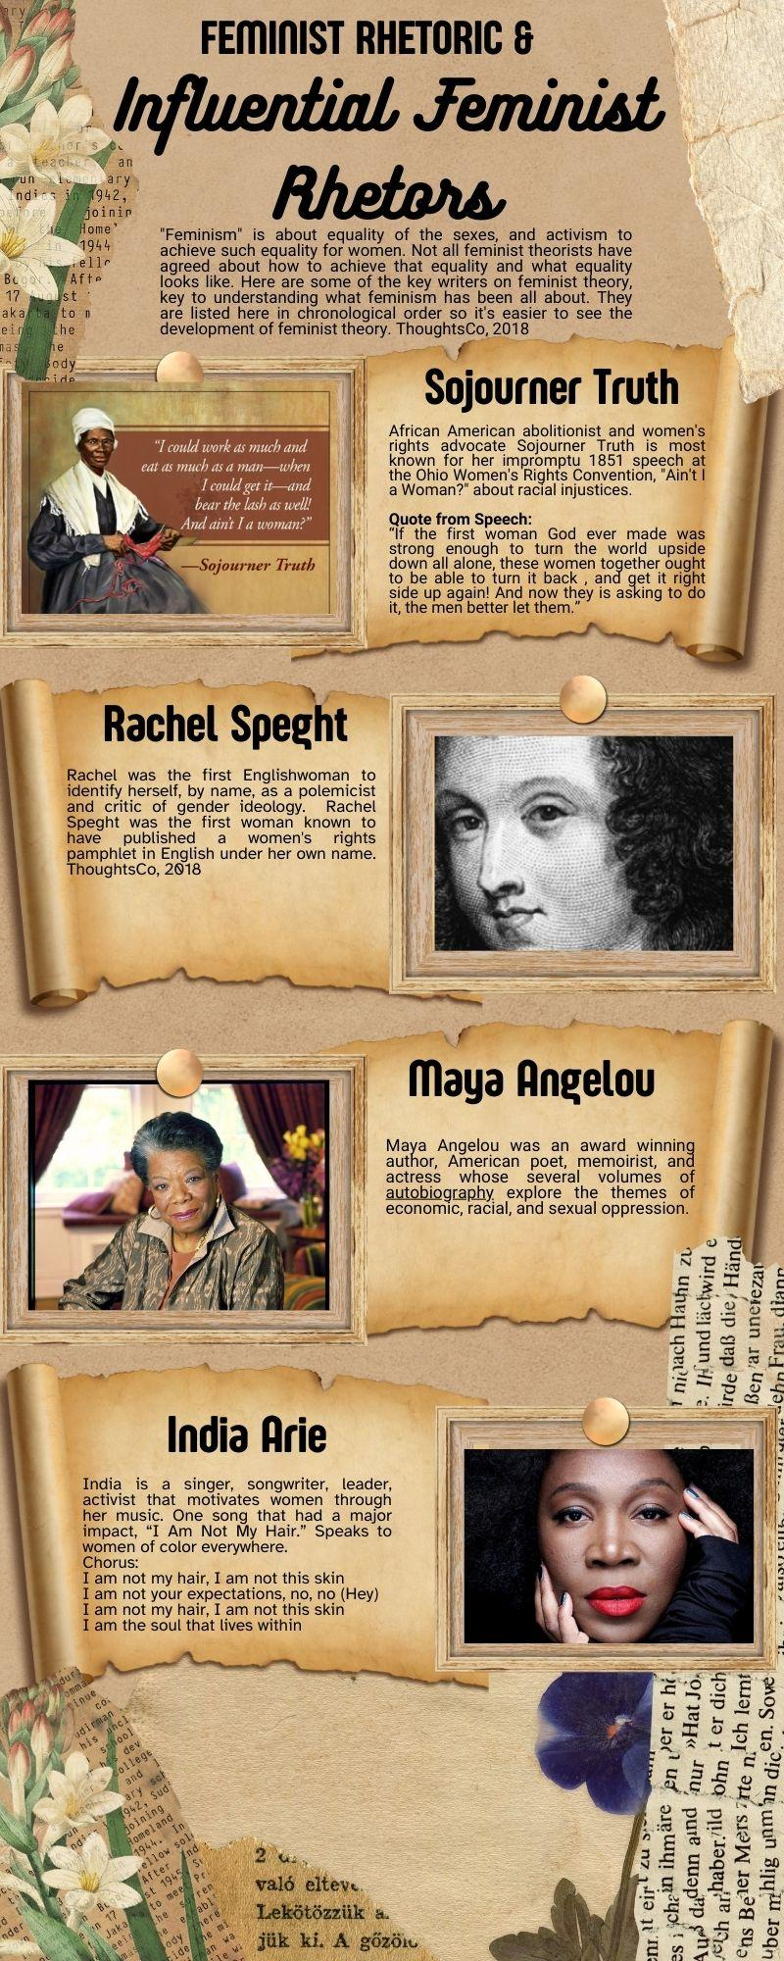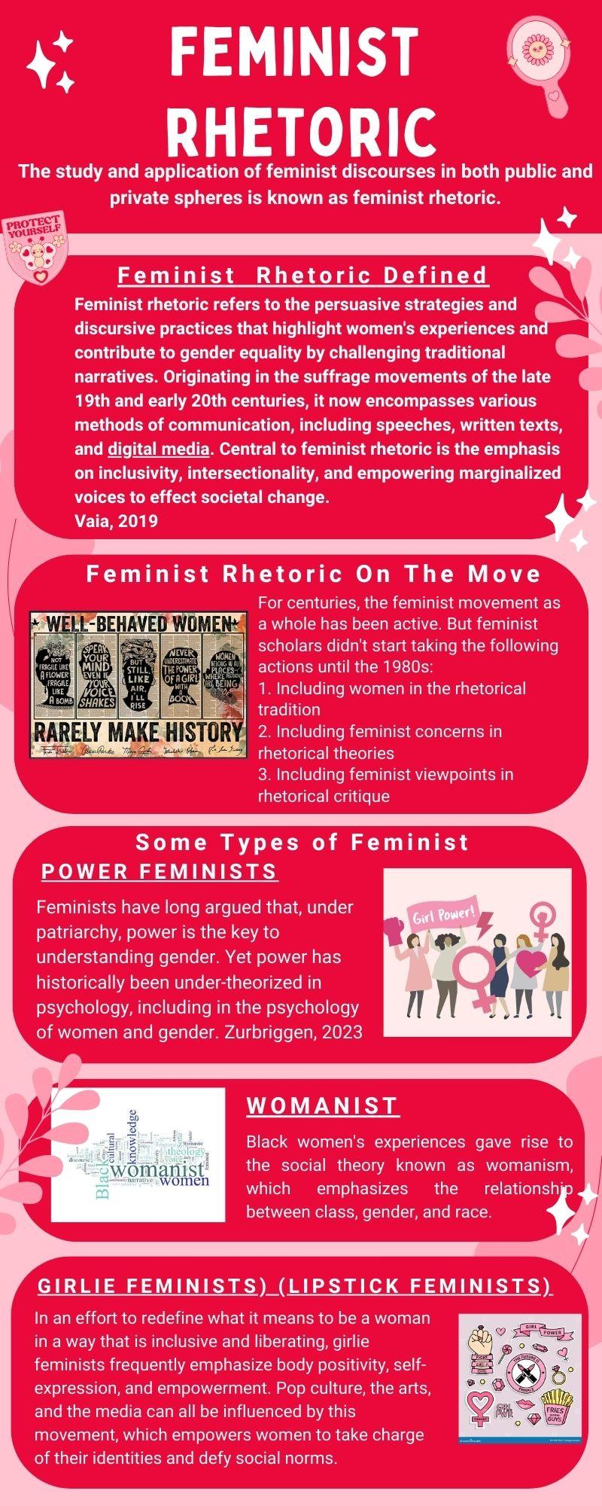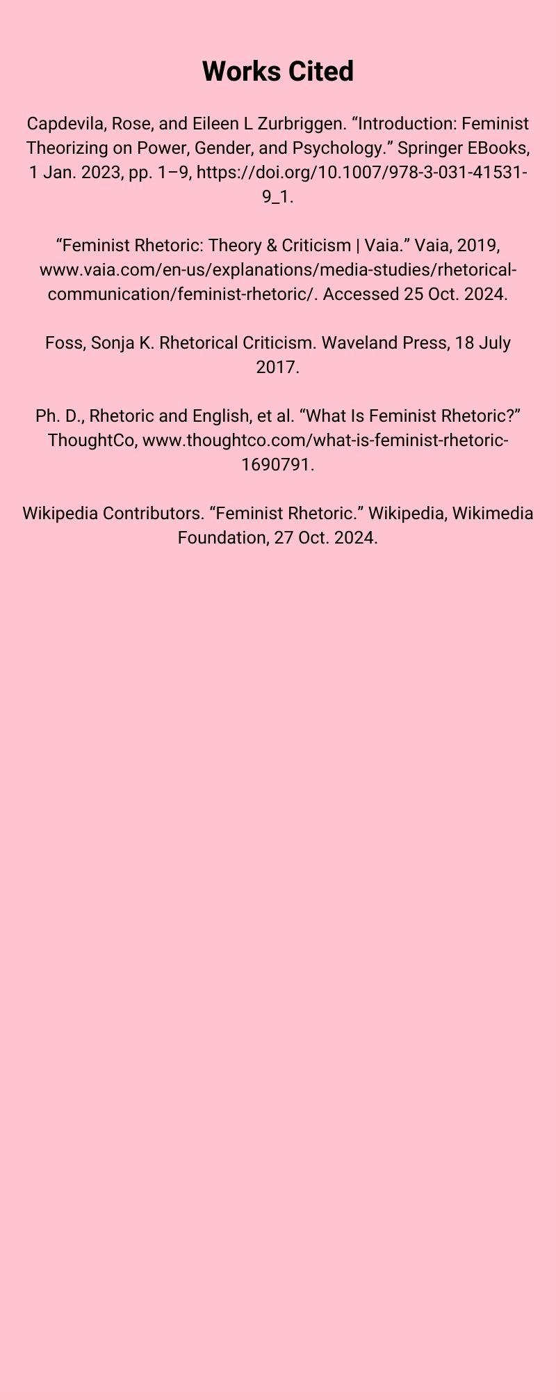

**Rhetorical Subfield Infographic**

Creating the rhetorical subfield infographics was challenging, but enlightening. Had I been asked to write an essay I could have created one easily, but this project required a little imagination and expertise. I firmly believe that it will all be useful in the future.

At first, I intended to create two infographics: one on black rhetoric and one on feminist rhetoric. But as I looked more closely at the project, I discovered that there was so much feminist rhetoric alone that the infographic designs' allotted space would not be nearly sufficient to convey all the information. I made two infographics as a result. One that offered the academic side of women rhetors, and another that included a small amount of foundation. Feminist discourse covers topics such as social justice and gender equality. It can promote educated conversations by increasing awareness of these important issues. Political and social environments have been influenced by feminist movements. By drawing attention to this rhetoric, we can inform others about the development of these movements and their effects. I think that by showcasing a variety of viewpoints, my infographic can empower women and encourage discussion and motivate change in addition to providing information.

The foundation was laid by the first infographic, Feminist Rhetoric, which included information on its history and development as well as other pertinent details like the many kinds of feminists. The information presented in the early publications dated feminist discourse to 1980. Nevertheless, more investigation starts to uncover women who were regarded as rhetors far before the 1900s. I understood right away that this was important and should be mentioned. I must admit that I had never heard of feminist rhetoric prior to this session, and I most certainly would not have thought of Sojourner Truth and a few of the other women mentioned as rhetors.

The selection of the women was based on the great differences and similarities that united them and continue to unite us today. At a women's convention, former slave Sojourner Truth bravely stood and delivered her speech, "Ain't I a Woman?" An English woman named Rachel Speght ran a journal dedicated to women's rights. Among many other things, Maya Angelou was an American poet and award-winning author. India Arie is an activist, singer, and songwriter. Despite their individual differences, all women are united by a centuries-old movement.

The information was hard to find. Normally, I would start based upon history and work from there. However, finding information for this particular topic was somewhat difficult. Therefore, I started with class readings and built research from that perspective. It was quite difficult to find some of the information. Many of the writings redirected to articles that weren’t readily available and required subscriptions. I learned to be quite the research strategist for this project and learned quite a lot in the process.